Much clearer disposal information for wet wipes is coming to a shelf near you! After years of legislative work, AB 818 has been signed into law by the Governor! This bill establishes the strongest “Do Not Flush” wipes labeling & public education requirements in the country.
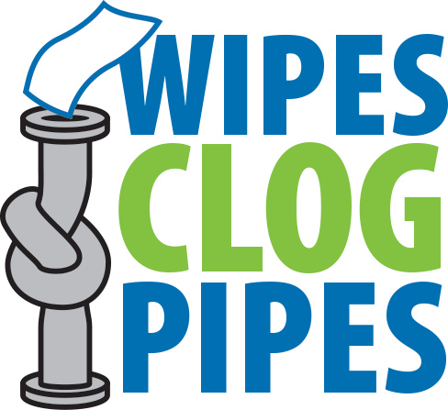
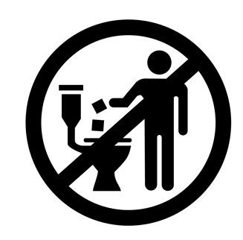
Starting in July 2022, in compliance with AB 818, all wet wipes packages are required to include a “Do Not Flush” symbol (check it out below!) and warning on each individual package. This is a huge win for consumers, infrastructure, for the environment, and for our sector!

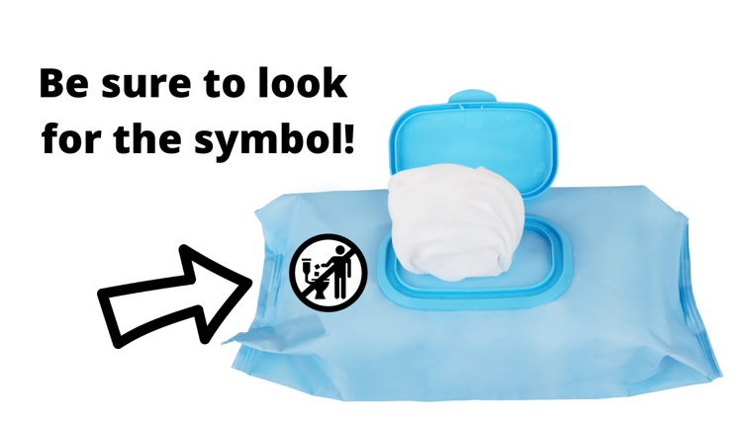
Governor Newsom signed AB 818 into law this week, requiring all packaging for diaper wipes, cleaning wipes, and cosmetic wipes to display clear “Do Not Flush” warnings. Look for the symbol like the one below starting in July 2022!

